Francesco Saverio Pavone  
European Laboratory for Non-linear Spectroscopy (LENS)  
University of Florence  
Via Nello Carrara 1  
50019 Sesto Fiorentino (FI), Italy  
Tel: +39-055-457-2480  
Email: francesco.pavone@unifi.it

13.05.2015

Manuscript Reference: NPh 15012SS

Title: “Comprehensive optical and data management infrastructure for high-throughput light-sheet microscopy of whole mouse brains”

Dear editors,

We would like to thank the referees for the thorough and careful consideration they have given our manuscript. We have made the changes suggested and addressed every question raised. We believe that the revised paper is stronger as a result. Details of the changes made can be found below. We enclose a copy of our revised manuscript which we hope is now suitable for publication and look forward to hearing your decision.

Yours sincerely,

Francesco Pavone

Reviewer Comments:  
  
Reviewer #2 (Reviewer Comments Required):  
  
It's a systematic and complex work, but they described very clearly. Overall, I only suggest that some detailed technical text may be moved to supplementary information.

*The paragraph on software organisation has been moved to the supplementary information.*

Reviewer #3 (Reviewer Comments Required):

This paper describes the design and implementation of a confocal light-sheet microscope for imaging whole and "clarified" brain from a rodent. It describes the detailed construction of the microscope including specifics of the software control and the optical components.

While the technical challenge of imaging the whole brain is well articulated, it is not clear what the scientific goal was or what novel methodology is developed to answer a scientific question. Hence, the conclusion seems to be hanging and does not clearly address a scientific feat. There are several issues mentioned in the conclusion (like aberration and the incorporation of adaptive optics), which would have been a very good optical problem to address and solved in this work. However, this is left for future work.

*Our submission is not a manuscript for a “standard” scientific paper answering a specific scientific question or demonstrating a novel technological development but rather represents an invited contribution to a special issue on “Light Microscopy on Connectivity”. The novelity lies in the presentation of a strigent and comprehensive framework for whole brain imaging at microscopic resolution.* *The meso-scale neuroanatomy imaged at micron-scale resolution in those data sets allows characterization and quantification of neuronal projections in unsectioned mouse brains.*

The technical feat (both opto-mechanics and software) and the rigorous description of the design, however, may well justify its significance to scientific community, but perhaps suitable in another journal like "Nature protocols" or a similar type of journal and not for a journal that promotes scientific novelty. Non-optics researchers will appreciate systems integration including the use of an open-source stitching software and pretty standard but elaborately described opto-mechanical design. This will be a good reference if one needs to build a custom-built light sheet microscope in addition to work reported by Torner, et al, Nat Prot (2014).

Specific comments:

1. Figure 6 shows a result that does not justify the rigor of the engineering detail presented in the paper. Description in the manuscript text is also not given enough significance. It is not presented or described in a way that one can appreciate the optimal resolution (x,y,z) as well as its extent in recreating an image of a whole brain. Fig. 6a only shows half the brain. Perhaps a 3D tracing software maybe applied to trace axonal projections.

*Figure 6 has been changed to include data on the resolution in a mouse brain data set:*

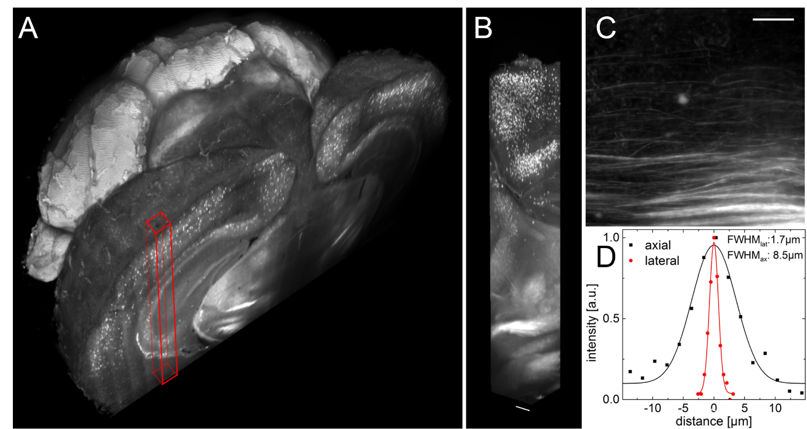

***Fig 6: Whole mouse brain tomography. Imaging of whole transgenic mouse brains treated with CLARITY and cleared with TDE 63% imaged with Olympus, 25X objective. (A) 3D rendering of a parvalbumin-dTomato brain. (B) 3D rendering of a stack from PV-dTomato mouse brain, scale bar = 400µm. (C) High resolution insert showing axonal projections. Scale bar = 100µm. (D) Lateral and axial FWHM of the intensity profiles through axon. Modified with permission from [12].***

*The text relating to Figure 6 has been changed to:*

***Some representative data produced by our microscope are reported in Fig. 6. With the apparatus described in this paper, whole mouse brains could be imaged in their entirety (Fig. 6,A), maintaining a high quality of the image also when going deep inside the specimen (Fig. 6,B). The resolution and contrast of the images allowed to clearly distinguish axonal tracts (Fig. 6,C) in the brain of a PV-cre-dTomato transgenic mouse, in which parvalbuminergic neurons are fluorescently labelled. Lateral and axial intensity profiles through a fine axonal projection were used to estimate resolution in a brain data set in terms of the FWHM (Fig. 6,D). The lateral and axial FWHM were 1.7µm and 8.5µm respectively, in agreement with the measurements on fluorescent beads. Whole-brain datasets as presented here can be used to localise cell distributions in 3D using automatic cell-detection software [7].***

2. Figure 8 is missing

*The missing Figure has been uploaded.*